Activity 18
Theory of Paradox
by Mark Lederer
University of Wisconsin, Madison

This classroom exercise focuses on the theory of paradox. Naturally, the students use the theory to divide people into easily identifiable groups. This exercise will help them apply the theory to look for common ground among different groups and explore the complexities of the interrelationships.
The figure below identifies the characteristics of each of the three camps in the theory: the Concerned Camp, the Satisfied Camp, and the Impatient Camp.
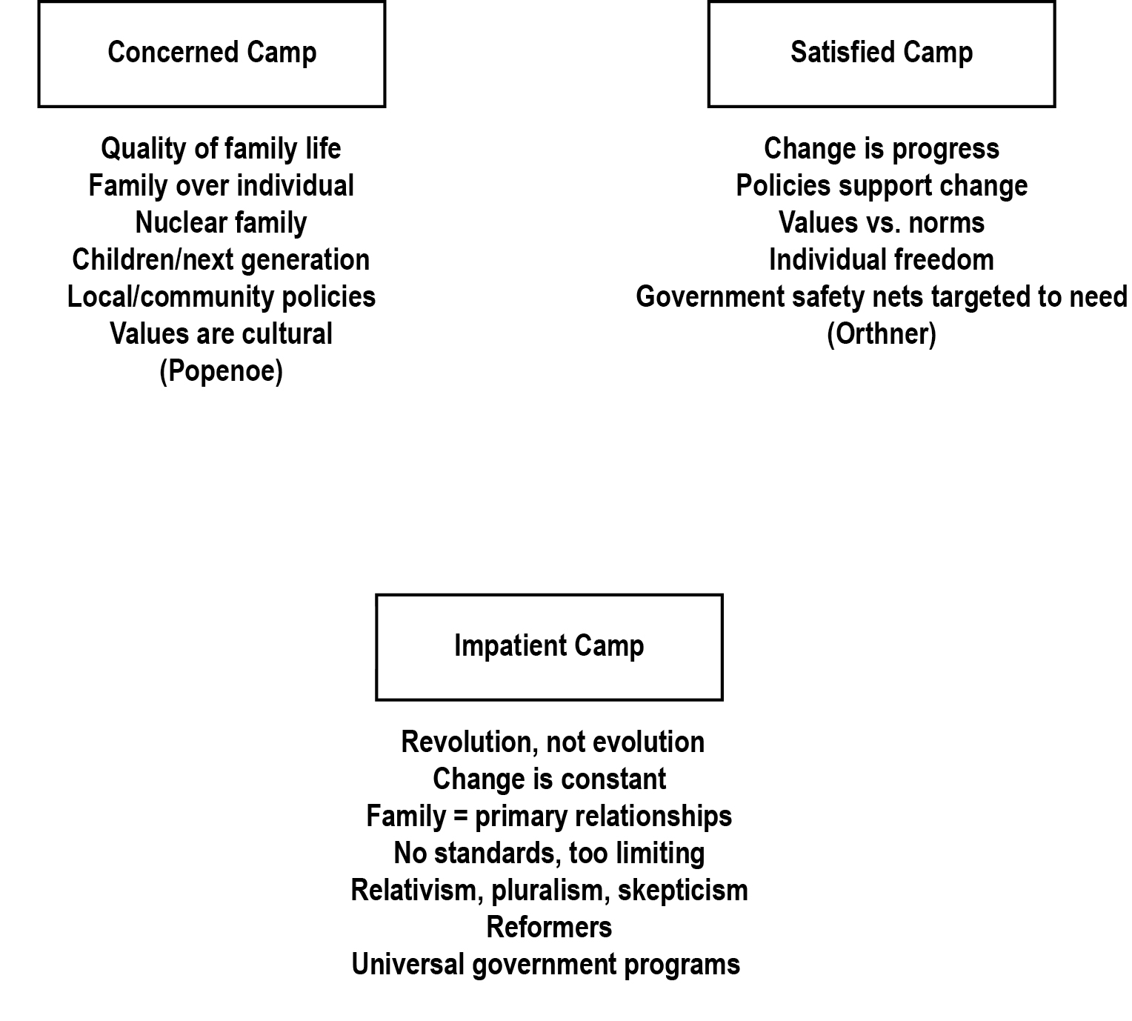
The second figure begins a discussion of the similarities based on common, but not identical, characteristics as represented by the lines between the camps.
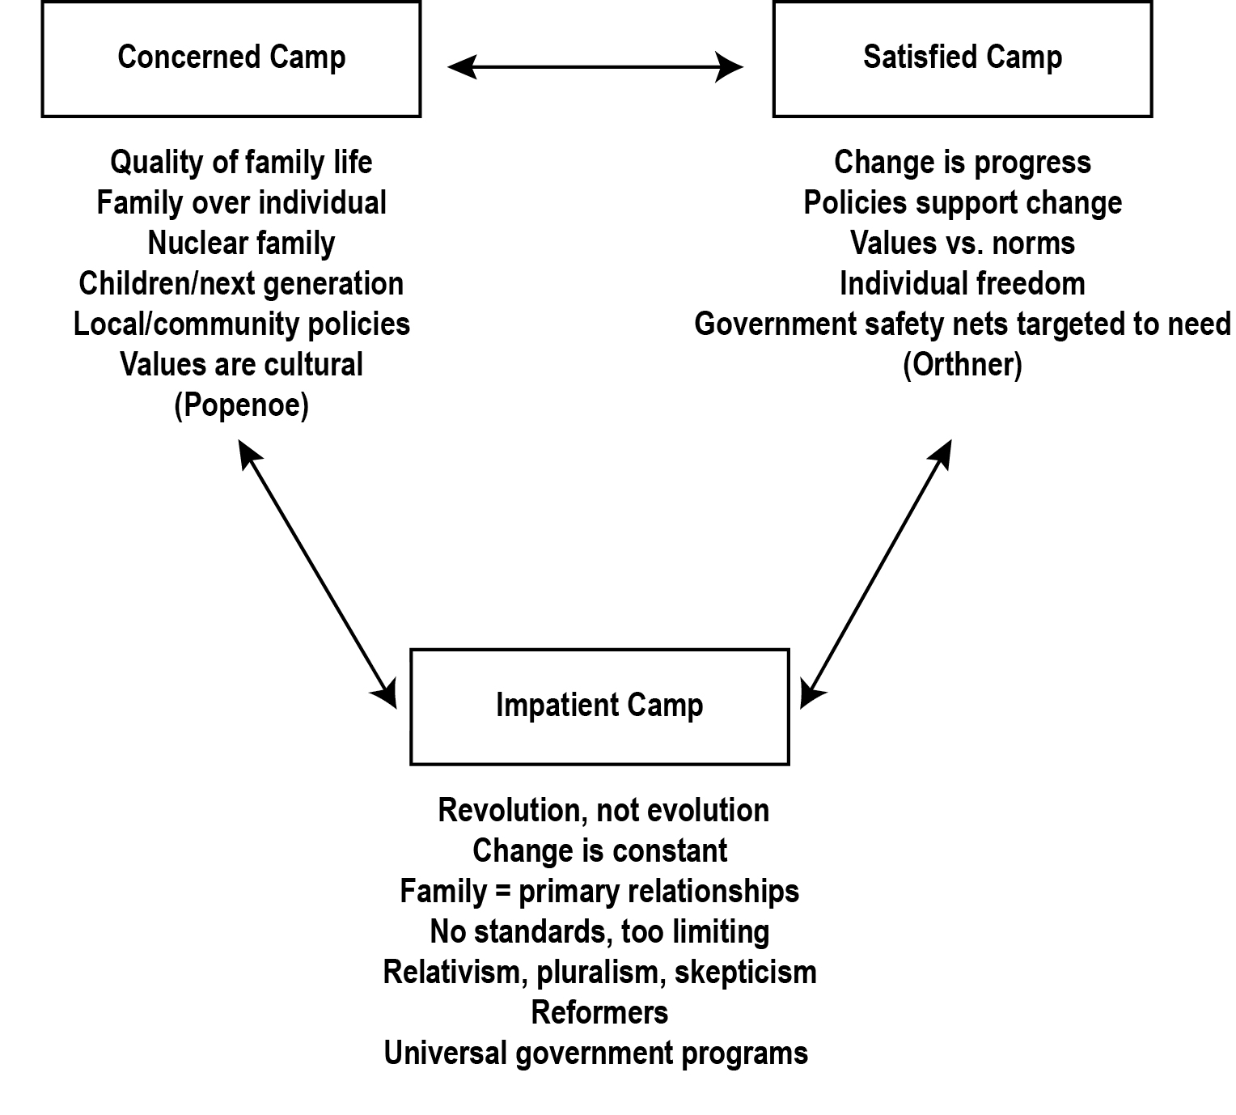
The third focuses our attention on the middle ground (represented by the circle) where members of the different groups might begin to see themselves as having some common interests. In theory, these figures have helped students think about opening up communication and breaking down barriers.
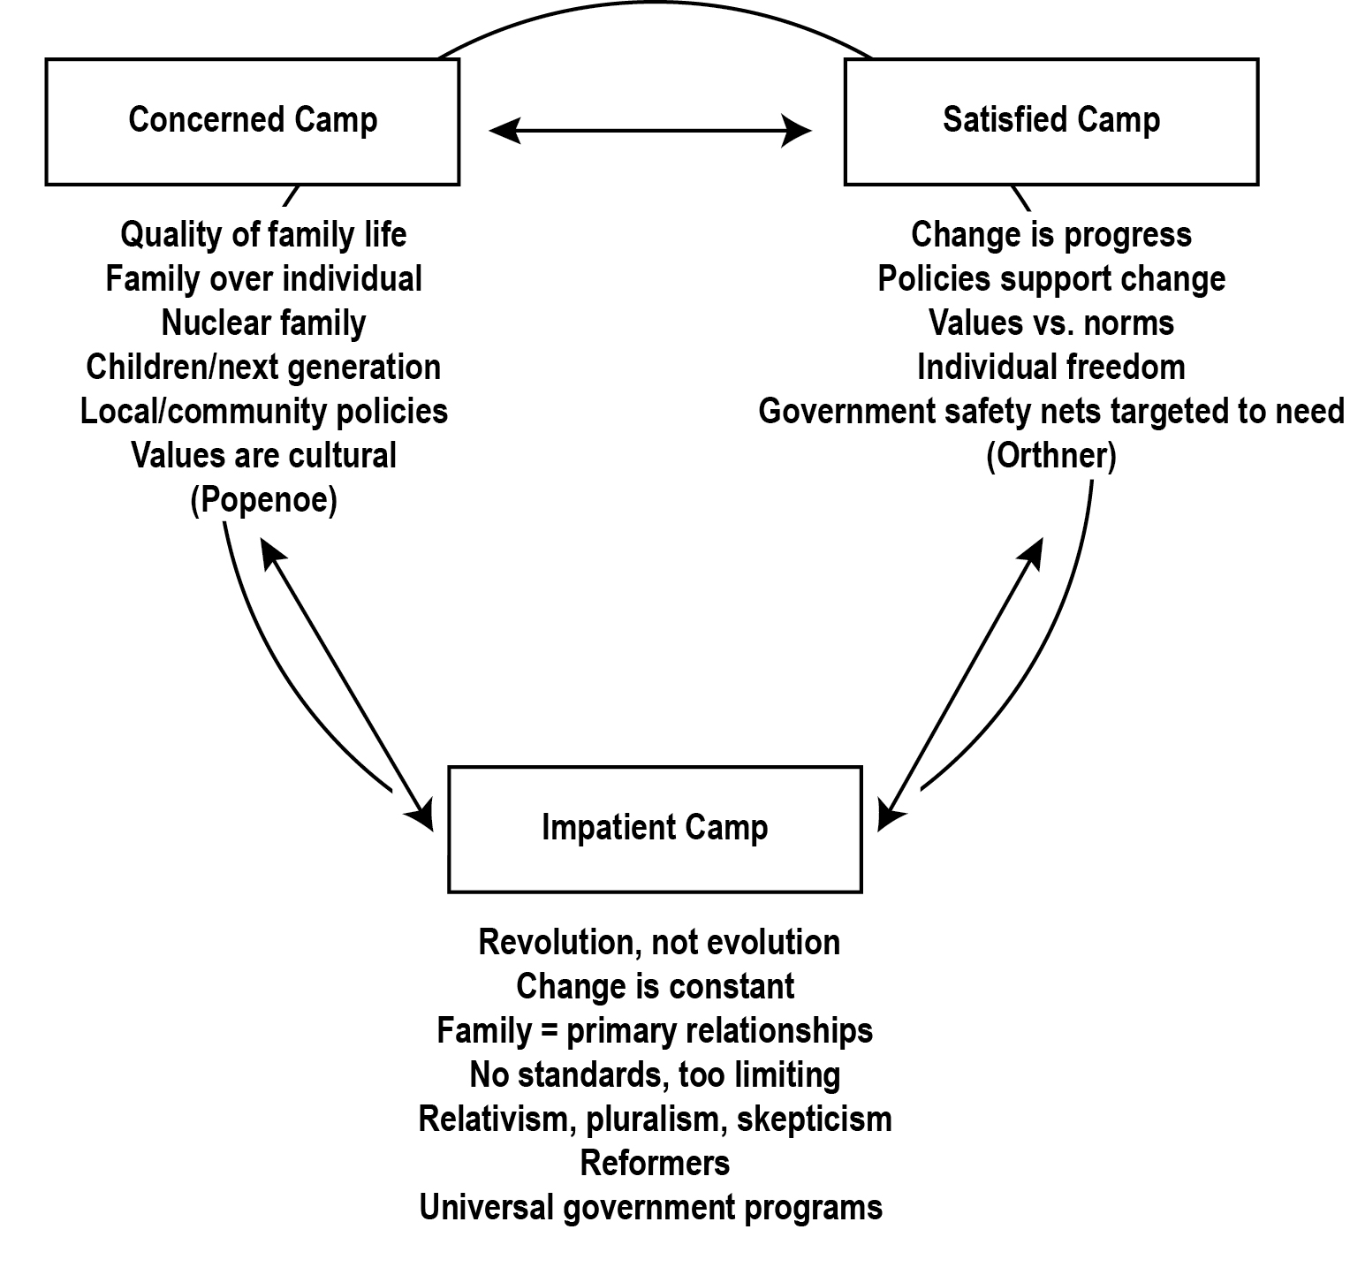
The theory can be applied to a number of specific issues. Retirement security is a great example (see figure below). The figure on the left identifies some of the characteristics you might assign each camp and the figure on the right lists the common characteristics that could lead to reform proposals capturing some of the different perspectives held by each camp.
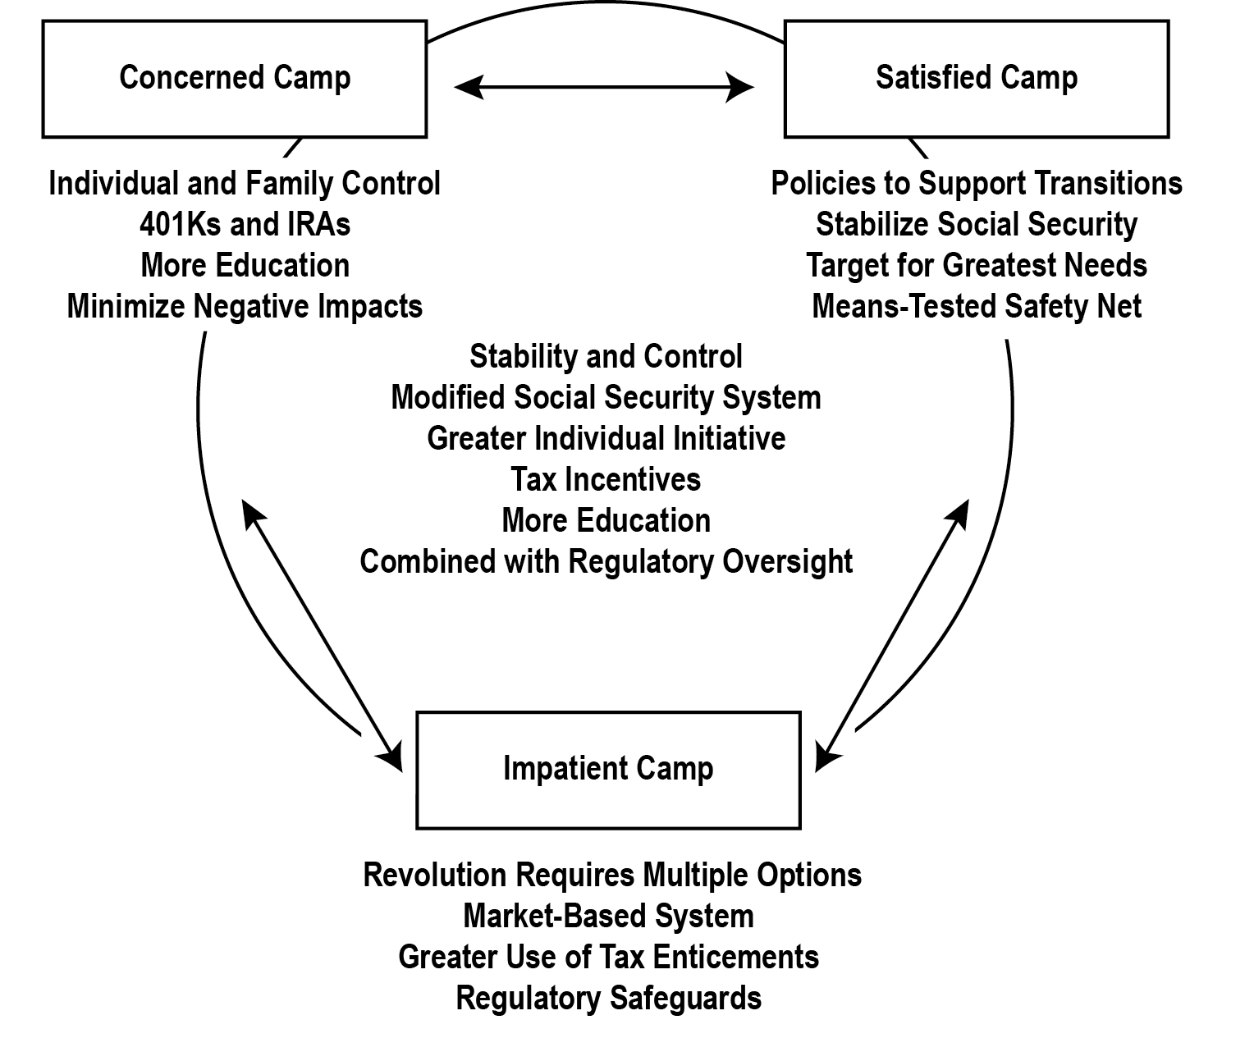
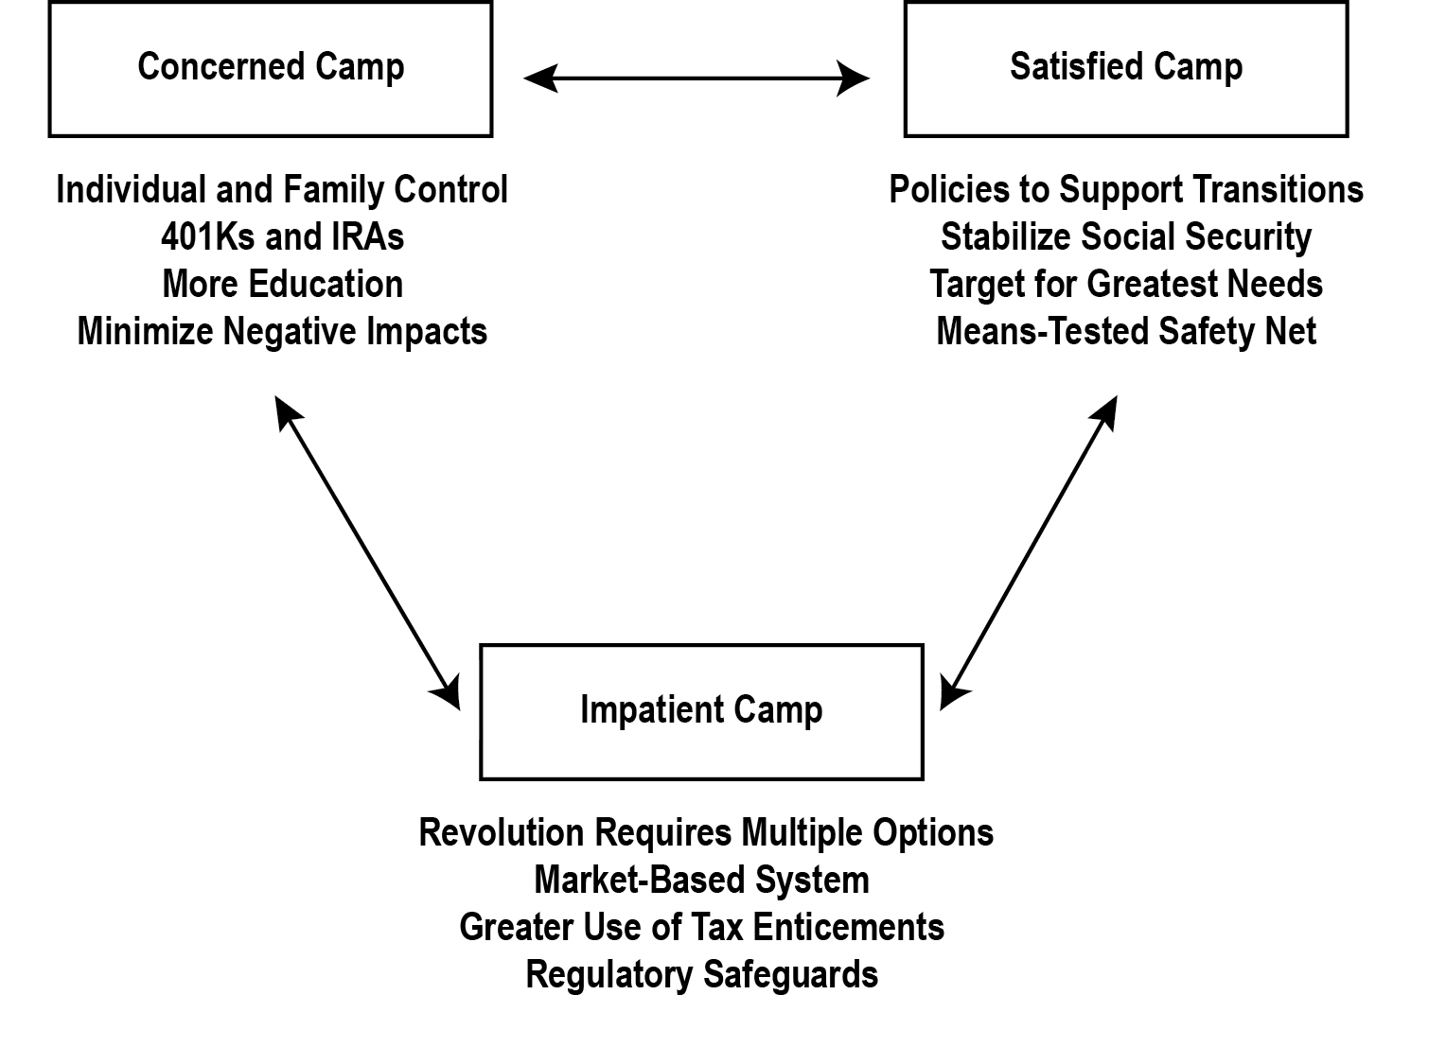

The following illustrations were developed using the alternatives and consequences model for public policy education, using deficit management as the issue to apply the elements of the model. In the first figure the problems are defined on the left and the potential answers are listed on the right. In the second figure, the policy options are assessed, allowing us to move from left to right and develop a solution.
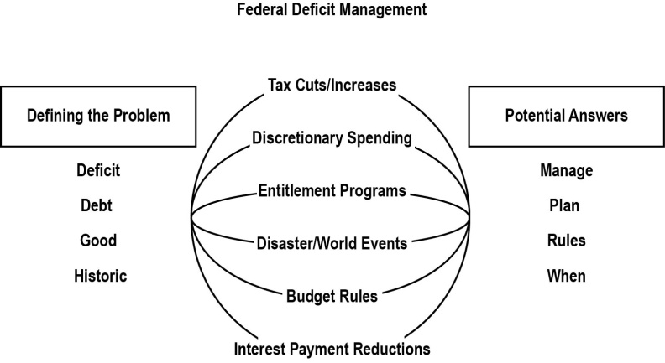
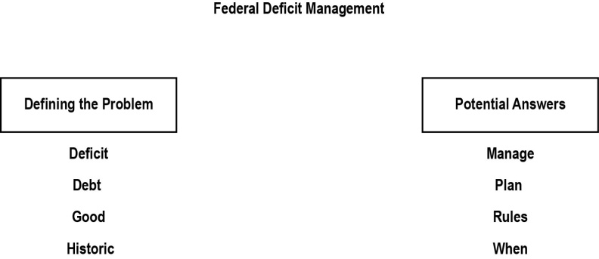

Note. “Theory of Paradox,” by Mark Lederer. Reprinted with permission.

