Activity 8
Constructing a Family Policy Map Based on
Walljasper’s American Political Landscape
by Karen Bogenschneider
University of Wisconsin-Madison
(“The American Political Landscape” is by Jay Walljasper
and was featured in the Utne Reader, November/December 1991, Issue 48.)

Family policy, like policy in general, is often conceptualized in simplistic either/or terms—left versus right, liberal versus conservative, or progressive versus traditional. To help students grasp the diversity of values and perceptions that underlie family policy in the United States, I begin with a foldout map from the article The American Political Landscape, by Jay Walljasper. Walljasper and colleagues identify prominent political philosophies and chart their relationship to one another. The parameters of the map are formed by four axes (equality versus liberty, freedom versus order, decentralized versus centralized, and liberal versus conservative). Based on this schema, the map charts 18 prominent views such as progressive, feminist, libertarian, neo-conservative, religious right, Christian left, Marxists, and grass-roots activists. For each position, the spokespeople, publications, music, and food are specified.
I use this map to initiate discussion on the values that underlie the debate over family policy in the United States using the following questions:
- How else could we draw the map?
- If we were to draw a family policy map, what might the axes be?
- cultural versus structural solutions
- individualism versus familism
- individual rights versus individual responsibility
- absolutism versus relativism
- federal versus local responses
- government policies versus civil society
Students speculate about what the axes would be if one were to construct a map of the family policy landscape. Student suggestions include equality versus prescribed roles, individual initiative versus government responsibility, self-fulfillment versus self-sacrifice, and tolerance versus conformity. The exercise underscores the diversity of values and perspectives that exist in a pluralistic society and explains, in part, the difficulty in finding middle ground on issues as personal and emotionally charged as those that constitute family policy.
Visit http://utne.com to obtain permission to reprint “The American Political Landscape.” Instructors will usually receive same-day permission.

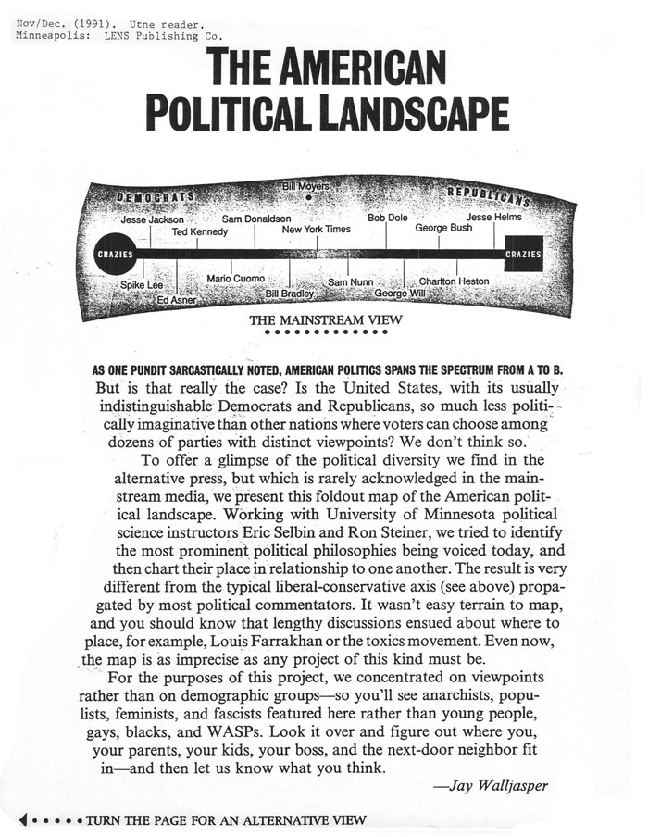

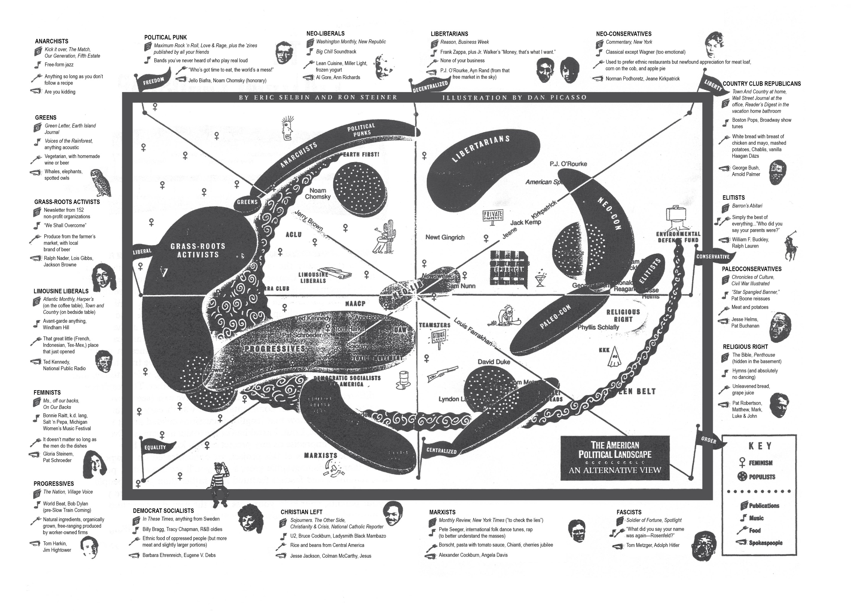

Note. “The American political landscape,” by J. Walljasper, November/December 1991, Utne Reader (Ogden Publications, Inc.), 48, pp. 287-289. Minneapolis: LENS Publishing Co. Reprinted with permission.

