Activity 10
Flinchbaugh’s Worm Exercise:
The Role of Facts, Myths, and Values in Public Policy
Adapted by Karen Bogenschneider, University of Wisconsin-Madison
from Barry Flinchbaugh, Kansas State University

Barry Flinchbaugh, Kansas Extension State Leader in the Department of Agricultural Economics, granted permission to reproduce the attached “worm” exercise which vividly illustrates the strengths and limitations of science in the policy arena. Flinchbaugh has used this exercise with audiences as diverse as an Eskimo tribe in Nome, Alaska, and a livestock association in Kansas. I have found this activity useful with both student and lay audiences.
By exploring the influence of facts, myths, and values, this activity serves as an excellent introduction to a unit on the role of the professional in influencing policy development. According to Flinchbaugh (1988), facts are verifiable statements of what is, myths are what people think is true and treat as fact, and values are people’s notions about what should be.
To illustrate each of these concepts, you will need to draw two worms, one red and one purple, according to the specifications given on the sheet that follows. The legs are drawn to make the shorter worm appear longer.
Explain to the group that the public issue under consideration is which worm is the longest. Ask everyone to vote by raising their hand—no fence sitters. Record the votes and recruit a volunteer to measure the worms with a yardstick. After seeing the worms measured, most people accept the result since there is universal agreement on the measuring stick. Inevitably, some people in the group vote that the worms are the same length, based on the “myth” that this is one of those psychological tests that only makes the worms look different sizes.
Next the group votes on which worm is the prettiest. Record the votes. Since there is no measuring stick for prettiness, this public issue cannot be solved by science and must be settled with value judgments. This issue must be resolved in the political arena with debate and compromise among diverse interests with divergent views.
Ask those people in the minority what political actions they would take. The group’s responses usually fall into two categories: working within the system to get the vote changed (i.e. lobbying, media campaigns) or throwing out the rascals who voted wrong (i.e., organizing a coup d’etat).
Thus, this activity demonstrates that social science research, while valuable in the political arena, has limitations. Social problems are identified when discrepancies occur between what is real and what is perceived as ideal (Ross & Staines, 1972). Research can contribute to problem identification by decreasing the body of myth and contributing to our understanding of reality. Social policy, however, tries to determine the ideal; research contributes little to a sense of what ought to be (Barrows, 1994; Seeley, 1985). Flinchbaugh has granted permission to reproduce the attached article which explains the activity in detail. If you use the activity, however, please notify Barry Flinchbaugh by writing Kansas State University, Department of Ag. Economics, 344 Waters, Manhattan, Kansas, 66506, calling (785) 532-1505, or via email: bflinchb@agecon.ksu.edu.

Two Worms: The Importance of Facts, Myths, and Values in Public Policy
by Barry Flinchbaugh, Kansas State University
Public policy is an identifiable course of action hammered out in the political arena to maximize the satisfaction of relevant interest groups in society and to improve the general welfare.
There are basically four points in this definition of public policy. “An identifiable course of action”—we are not talking about theory or the dream world. In the real world, public policy is “an identifiable course of action, hammered out in the political arena.” The purpose of public policy is “to maximize the satisfaction of relevant interest groups.” There is no question that, in this country, we have become a government of special-interest groups. And they make public policy. I tacked a phrase on the end of the definition, “to improve the general welfare.” You might question that. Some people would argue that the general welfare has not been improved; that all we really have is a government of special interests. But, over the long haul, if we look at public policy, in general, I would argue we have improved the general welfare.
Let us take this a step further. Public policy is developed through debate and compromise. That word, compromise, may be the most important word we will use in discussing public policy. Debate and compromise occur among diverse interests. Those diverse interests have differing views about economic and social problems, and the government’s role in dealing with them. In the final analysis, many public policy issues involve the role of the government. An issue that comes to mind has been debated long and hard for many years. I refer to the government setting dietary goals. If any of you deal with the livestock industry, you are well aware of the issue. I like to eat, and it shows. I can say, using my value system, that it is none of the government’s damn business what I eat! The real issue is the government’s role in our eating habits. It is not “Should we eat more or less meat?” It is not those specific goals that the government sets. It is really a question of the government’s role. Should the government just provide information on nutrition; make it available; provide educational programs; or should the government establish strict dietary guidelines for the American people? Frequently, public policy issues simply become a question of the government’s role.
What are the characteristics of public policy issues? Public policy issues are normally stated in terms of symptoms rather than the problem itself. Public policy issues are public policy problems stated in terms of symptoms. Specifically, public policy issues:
1. Require a group decision. We are not talking about individual problems. We are dealing with group problems. These problems require a group decision.
2. Solutions are based on value judgments. If we can settle the problem through scientific analysis; if we can come up with the answer in the laboratory, it is not a public problem. Public problems involve value judgments to arrive at solutions. There are no “right” or “wrong” answers to public policy solutions. I tell my audiences in seminars in Kansas, right up front, “You all came in here with the answer to the problem we are going to discuss. And you might as well understand and convince yourself that your way of doing it is never going to happen.” If you can convince yourself of that, you are a long way toward beginning to discuss the problem rationally. The answer will be a compromise based on value judgments. Your way of doing it will not happen.
3. Are of broad interest and concern. Frequently, when they are together in a group discussing public issues, people will say, “Something ought to be done.” Public policy issues evoke broad interest and concern.
4. Are controversial. If you are not dealing with a controversial issue, you really are not dealing with a problem that concerns the public. Public policy issues are controversial, and that is why Extension educators require a unique methodology to deal with them.
5. Are recognized by key decisionmakers as a problem. A public policy is really not an issue until the key decisionmakers recognize the problem. It does not really matter what you all think in your local coffee klatch, if the key decisionmakers are not convinced it is a problem. Such recognition is required to arrive at a solution.
Issues often are stated in terms of symptoms or solutions, rather than in terms of the problem. A few weeks ago I made a rather sad journey back to my alma mater, Purdue University. The old guru of public policy education had passed away— “Heavy” Kohlmeyer, at 85 years of age. He and Dr. Carroll Bottum, at Purdue, basically put together this body of thought we use in public policy education. I have always considered myself extremely fortunate to have studied at the feet of those two gentlemen. And, if you knew them, that is a literal statement, because they were in charge. They directed a public policy education program in Indiana in the 1930s on social security. Indiana is a conservative, “red-neck” state, even today. In those days, if you dared mention the word “social security” in rural Indiana, you were “pink” at best, and downright communist at worst. You were promoting the ideas of that wild-eyed, liberal New Yorker, Franklin D. Roosevelt. But these two gentlemen directed a policy education program on social security.
The first problem they had was to define the problem. What do you think the problem is, since we are still dealing with social security as a public issue? What is the real problem? The issue in those days was “Should we or should we not have social security?” The issue today is “How to fund social security.” Is the real problem the distribution of wealth? Is it really a retirement program? Helping people survive retirement? Whose responsibility is it to fund retirement? Quality of life for retired folks? The issue, as stated back in the 1920s, was “Should we establish social security?” The problem is how to take care of old folks. Who’s responsibility is it, and what is the government’s role? Think how quickly one could defuse a hot controversial issue by phrasing it that way, instead of going in and saying, “Well, tonight we are here to discuss whether or not we ought to have social security.” Immediately there will be two sides—the liberals and the conservatives. If, instead, you go in and say, “Tonight we are here to discuss how to take care of old folks,” is anybody in the audience going to disagree with that? So it is very important to get to the problem immediately. Get away from the symptoms or the issue in the political context. Get to what is really concerning people—the common ground.
Before Nye provided tax alternative seminars in Kansas, we were told what the issue was, and what the problem was—taxes are too damn high! We diffused that issue immediately. We put it in rational terminology by saying we accept as given the cost of government. We are not here to debate the cost of government. The problem becomes, how to fund it. More specifically, what should the tax mix be to fund it? How much from each tax? The controversy was over the property tax. So the problem became how much we should get from each of the three major taxes—property, sales, and income—to fund the government. Immediately, we had that issue in a decisionmaking framework, since we were discussing the problem, rather than the symptoms. Let me try to diagram all this and get at this question: How are public policy decisions made? This is a public issue—a problem. Folks are saying something ought to be done. Some of them are saying there ought to be a law. So that is where we begin. It may begin in a local tavern, church pew, or club. There are some known facts about each public policy issue, as well as an abundance of myth. Then, each of us has his or her values. And each of us assumes this country is a Jeffersonian democracy in which everyone is welcome to his or her own set of values.
One of the things that you need to remember as an Extension educator is that, just because you have studied the issue, just because you have a degree behind your name, and just because you may be the “expert,” does not make your values superior to anyone else’s. There is a set of facts about each public policy issue. There is an abundant supply of mythology; and we all have our own values (see Figure 1). Just think of facts, myths, and values being put in a gunny sack and being redistributed, shaken up. All three come into play.
A fact is a verifiable statement of what is. The sales tax in Kansas is 4 percent; that is a fact. Social security is partially funded out of current tax dollars; it is not a long-term pension fund. Current workers are paying the bill for those who are drawing retirement benefits. Those are all facts that can be verified.
A myth, in the public policymaking process, is treated exactly the same as a fact, because a myth is what people think is fact. The real purpose of public policy education is to establish fact and destroy mythology. If we get the job done; if we establish fact and destroy mythology, we have basically completed our task as a public policy educator. I look at that as the main purpose of public policy education—to increase the body of fact, to increase public understanding, and to disprove mythology.
Values are what should be. Values cannot be proven right or wrong. Part of the government’s responsibility is to look after old folks. That is a value judgment. It cannot be proven right or wrong. It is the government’s responsibility to ensure economic justice. That is an interesting term. Everybody is for economic justice; it is like God, motherhood, apple pie, and parity. You cannot oppose economic justice. Let us define economic justice and use it to make the diagram in Figure 1 much clearer.
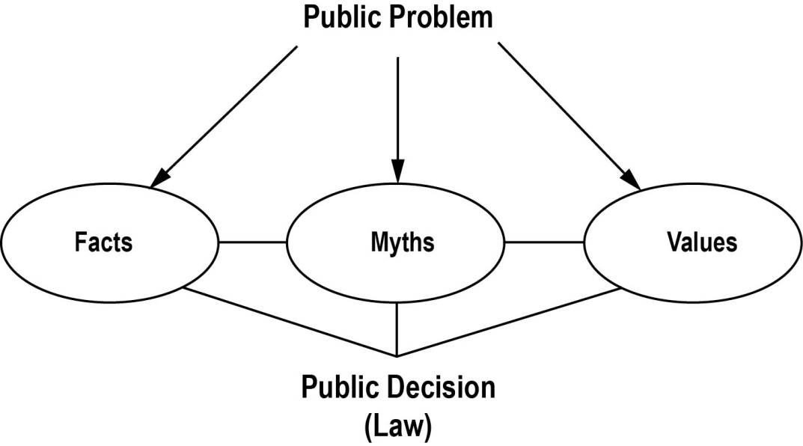
Figure 1. How public decisions (laws) are made
There are three definitions of economic justice:
1. Each according to contribution. This is the old principle of free enterprise, agricultural fundamentalism, or whatever you want to call it. As it was described to me in China, the last time I was there, “no work, no eat”—that is, each according to contribution. If you do not contribute anything, you do not get anything.
2. Each according to need. This definition is on the opposite end. Each of us has a basic set of needs—we need food, water, shelter, clothing, and other necessities.
3. Each the same. I can prove that this definition of economic justice is a myth, because treating each the same really does not turn out that way. Let us take a 16-ounce steak. We are going to set two plates here. One is mine; the other plate is for a petite young lady. She does not eat very much steak. About 6 ounces will do, but I need 16 ounces. I am going to get more satisfaction out of that sixteenth ounce than she will. This is the concept of marginal utility. We do not all need the same to have the same degree of satisfaction.
We will argue definitions: (1) each according to contribution, and (2) each according to need. This has been a basic political issue in this country. Politically, we have settled it with an interesting solution. The definition of economic justice, politically, has become each according to minimal need, then according to contribution. Does Ted Kennedy believe in that? Does he? Yes! How about the President, does he believe in that? Yes. In fact, he has a beautiful political term for it—safety net. In many public issues, the real debate centers around the definition of those words, or in Reagan terms, the safety net. When it comes to public welfare, Teddy Kennedy’s safety net has very small holes in it. The President has larger holes in his. So the issue is the size of the holes in the net that describes the current philosophical political debate in this country. It is down to that very simple question: the size of the holes in the net. That is what the farm bill debate was all about!
Facts, myths, and values are involved in every public issue, and out of that comes public policy—a law, a regulation, an executive order, among others. The Kansas sales tax is 4 percent. That is a fact. Those who believe in small holes in the safety net immediately argue that the sales tax is regressive; that is a myth. Not all sales taxes are regressive. If food, clothing, shelter, drugs, medical bills are exempt, a tremendous amount of the regressivity has been taken out of the sales tax. So, not all sales taxes are equally regressive. Not all sales taxes tax the poor relatively more than the rich. Objectively, one cannot simply make the judgment that all sales taxes are bad because they are regressive. Some of the regressivity can be removed. Explaining that fact destroys a myth, and separates fact from myth and values. We have a terrible time understanding value judgments. How big the holes in the net should be requires, in the final analysis, a value judgment. The illustrations in Figure 2 explain value judgments beautifully.
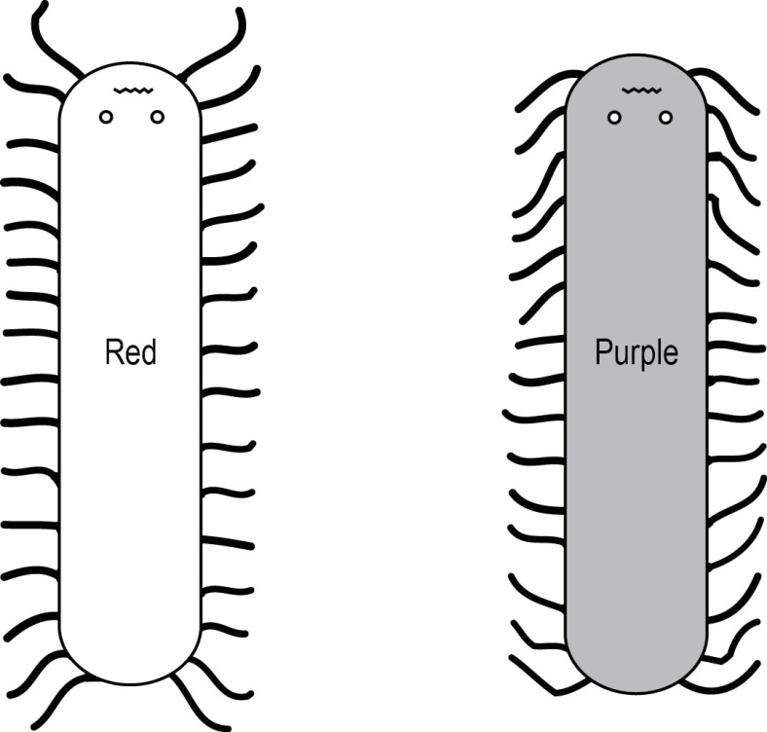
Figure 2. Two worms
Figure 2 shows a pair of worms. We have a public issue here that we have to settle. We are going to settle it in this room, democratically—one person, one vote. The public issue is, “Which one of these two worms is the longest?”
[Note: This illustration was used in the public policy education class at the Extension Winter School in Tucson, Arizona. The dialogue follows.]
Which one is the longer? Everybody votes, no fence riders today. Let us see the hands. How many think the purple worm is the longer? How many think the red one is longer? How many think that the worms are the same size? Let us measure them. The purple one is 19-1/2 inches and the red one is 17-1/2 inches long. The illustration is designed as an optical illusion to look the same, when actually they are different sizes. We have settled the issue with little difficulty.
Why? The one-foot ruler is a measuring stick. There is universal agreement that there are 12 inches in that one-foot ruler. We can settle this issue in the laboratory without a value judgment. This is really not a public issue; in this case, there is universal agreement on the size of the holes in the net.
Now we have another issue that we are going to settle. Which worm is prettier? Or, as a lady said to me one time, “Which is the least ugly?” How are we going to settle that? Do you know of any measuring stick on prettiness that is universally acceptable like the one-foot ruler? Let us vote. How many think the purple worm is the prettier? How many think the red one is the prettier? Only one said the purple worm is the prettier. We are going to pass a law declaring the red worm the prettier.
Values are involved. The one student was clearly outvoted. We made a decision that the red worm is the prettier, and the student is temporarily “wrong.” Or, at least she did not get her way. But she basically has two options. She can work within the system to change our minds, and get the vote changed. Or, as is done in many countries around the world, there could be a coup; just overthrow the government. Throw out the reds, bring in the purples. Do you see the difference? There is no measuring stick for pretty that is universally accepted. When a measuring stick on which there is universal agreement is not available, we settle issues with value judgments. We do this through two systems: compromise in a democratic society, or dictatorship.
Value judgments apply when there is not complete agreement on the measuring stick; then, we have a public issue. The issue cannot be solved by scientific analysis. It must be solved in the political arena, through debate and compromise among diverse interests that have divergent views.

Note. “Two Worms: The Importance of Facts, Myths, and Values in Public Policy,” by Barry Flinchbaugh. Adapted with permission. Reprinted with permission.

